create project name : assignment7

server:glassfish

java ee version : ee 7

finnish

click on assignment7 add web service :MyCalculatorWebService

click on webservice and add operations return num1+num2

build the assignment 7

deploy assignment 7

right click on:MyCalculatorWebService and click test web service

create new project : CalculatorWebServiceClient

same above steps

index.html

create form windows->ide tools->pallet

drag form : action:CalculatorServlet ->GET->ok

take 2 input field and 1 submit button: refer image

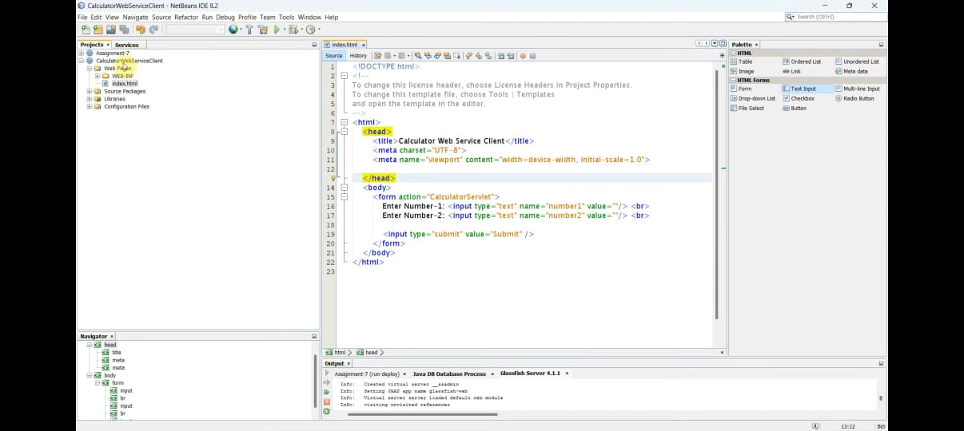

cliek on : CalculatorWebServiceClient the add new web service client

browse the assignment 7 webservice file and click ok ->fininsh

now in refernce folder youll see the refrence to the service created earlier

right click on :CalculatorWebServiceClient add servlet : CalculatorServlet->next click the checkbox: add information to deployment->finish

drag the myCalculatorWebServices to servelet

refer image:

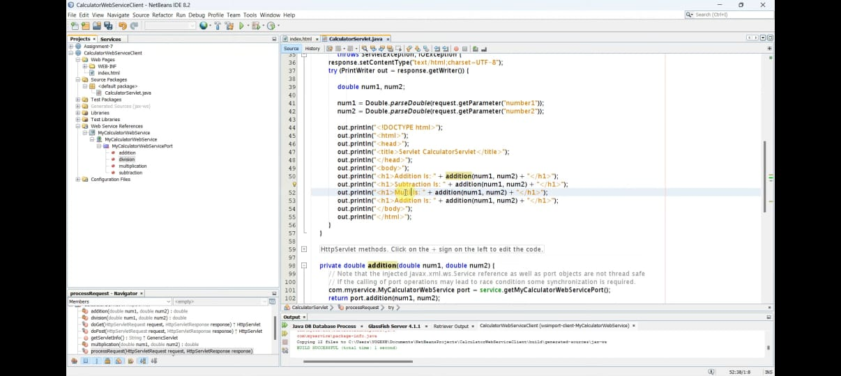

clean and build and then click on the index.html from project 2 and right click and run file

if required add css to index.html

